

DEVOPS FOR CLOUD COMPUTING
Assignment

Name:
Tehreem Mirza

Registeration No:
FA22-BSE-088

Section:
BSE-8B

Submitted To:
Sir Muhammad Ibrahim

Task 01 : Install nginx or Apache and change default page with your own cv.html custom page.
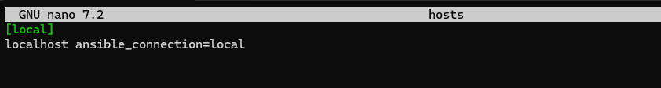
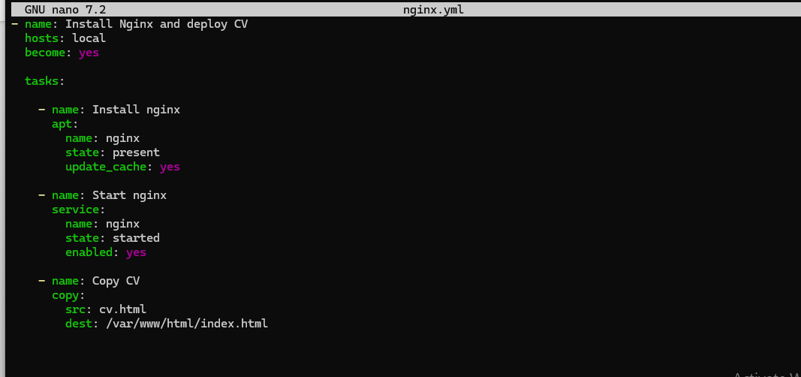

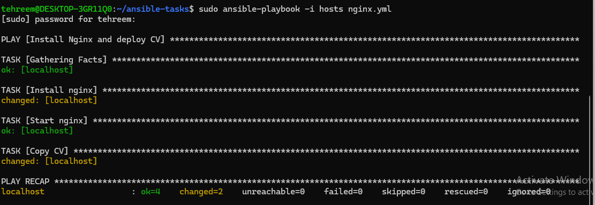

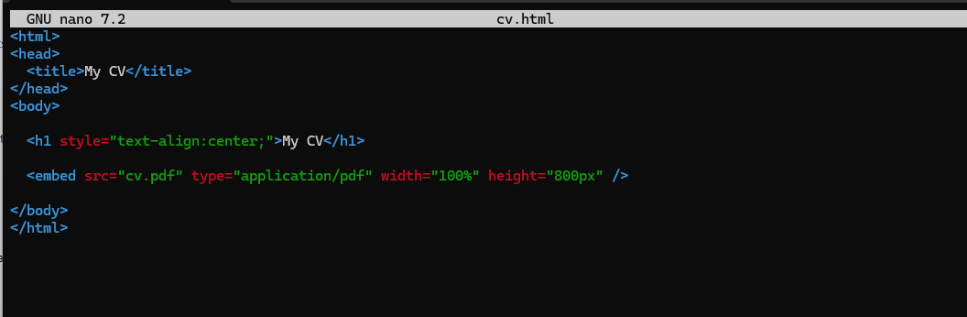
Updated nano.nginx file
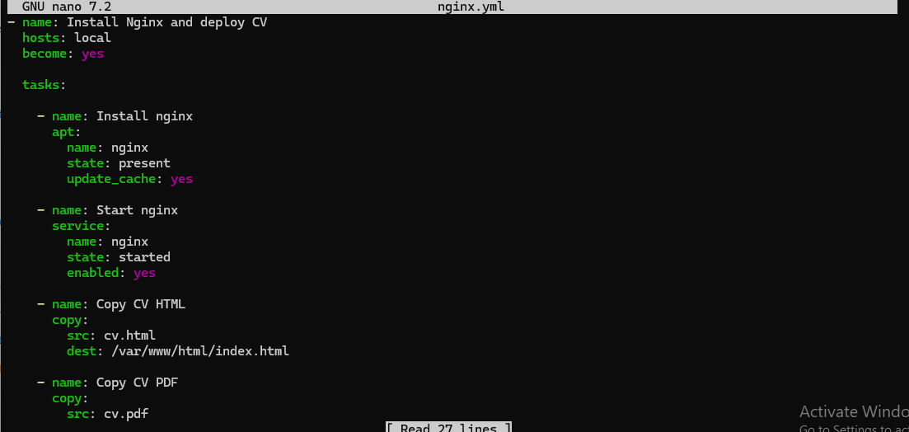
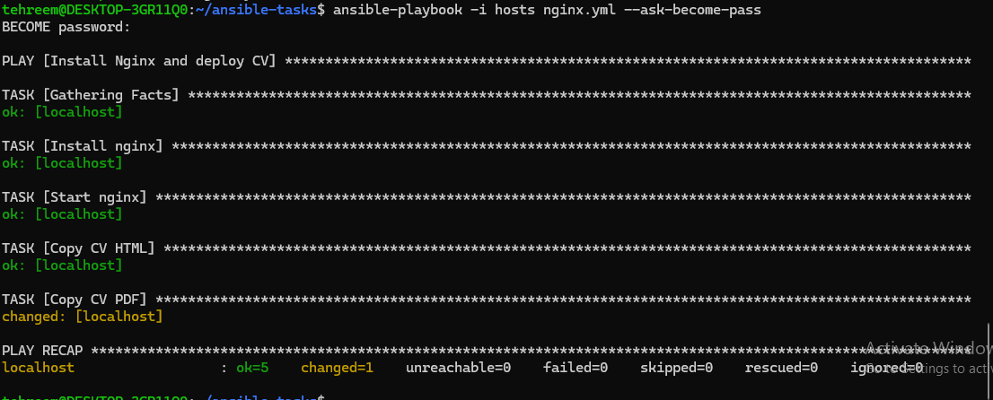
Localhost:
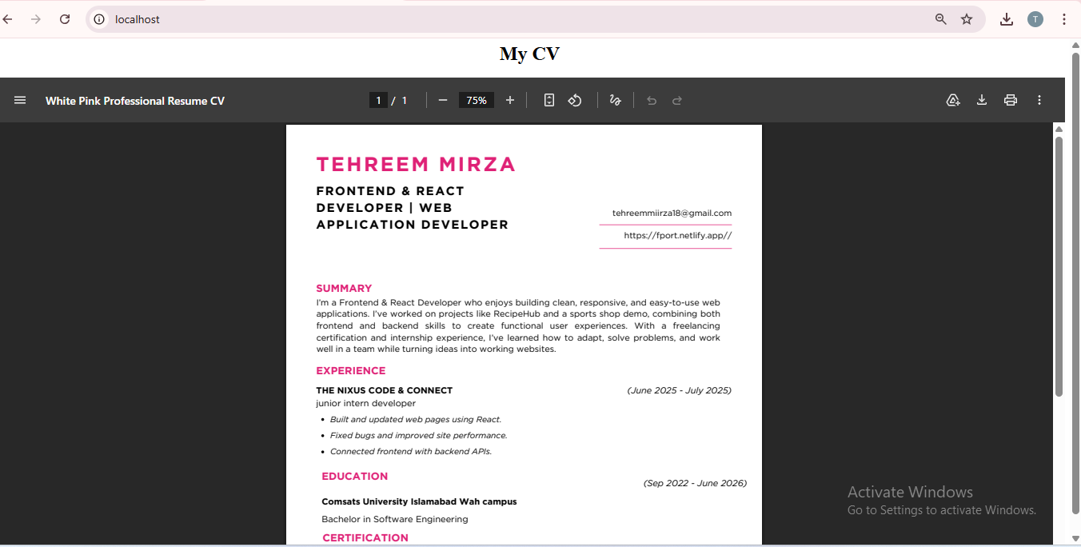

Task 02: Create 2 users on your Linux machine using Ansible playbook.


